KIHUNGYA HEALTH FACILITY
S/N | Name of Facility | Picture
1 | Kihungya Health Facility | 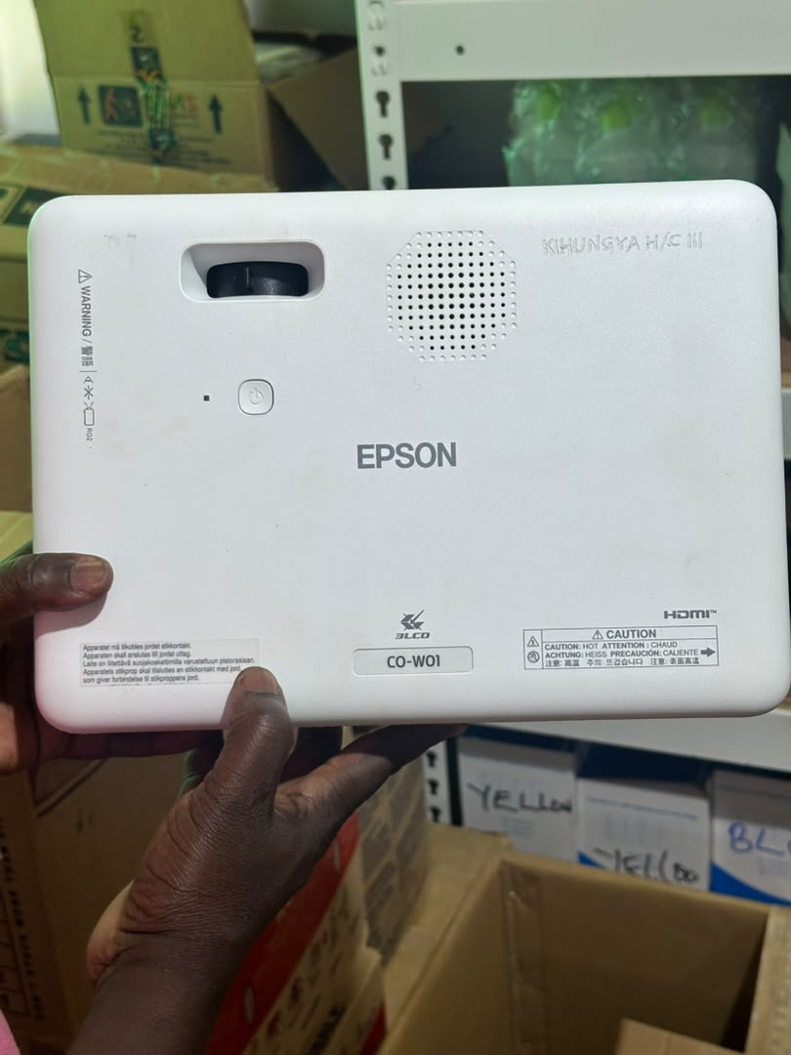
2 | Kihungya Health Facility | 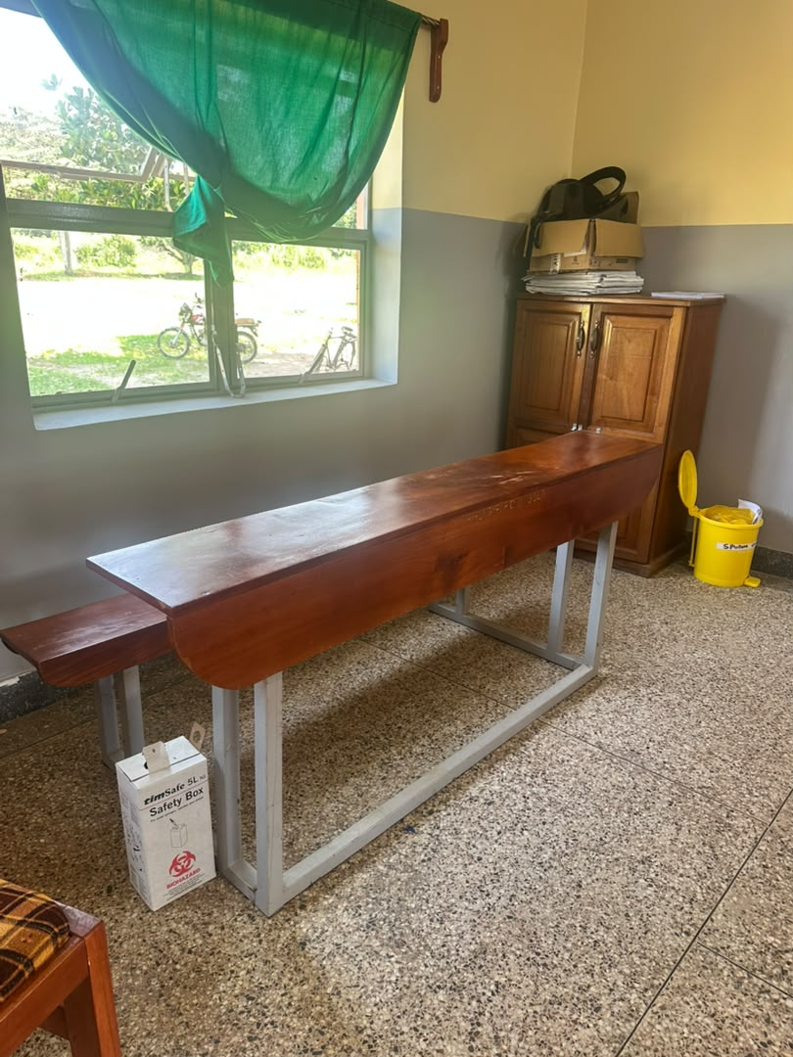
3 | Kihungya Health Facility | 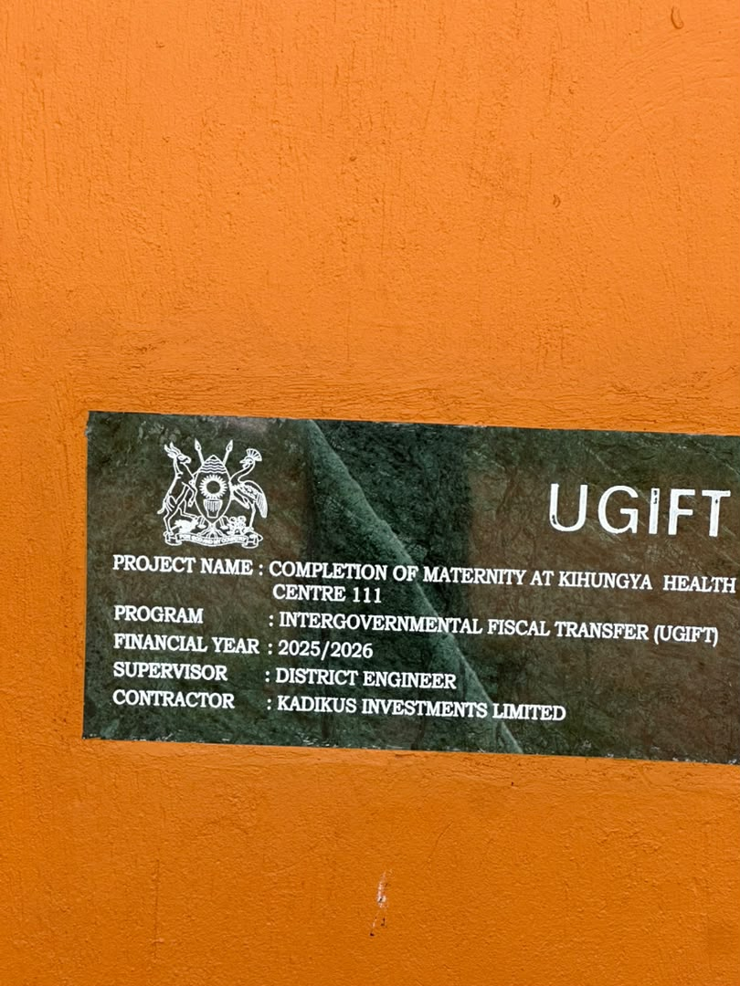
4 | Kihungya Health Facility | 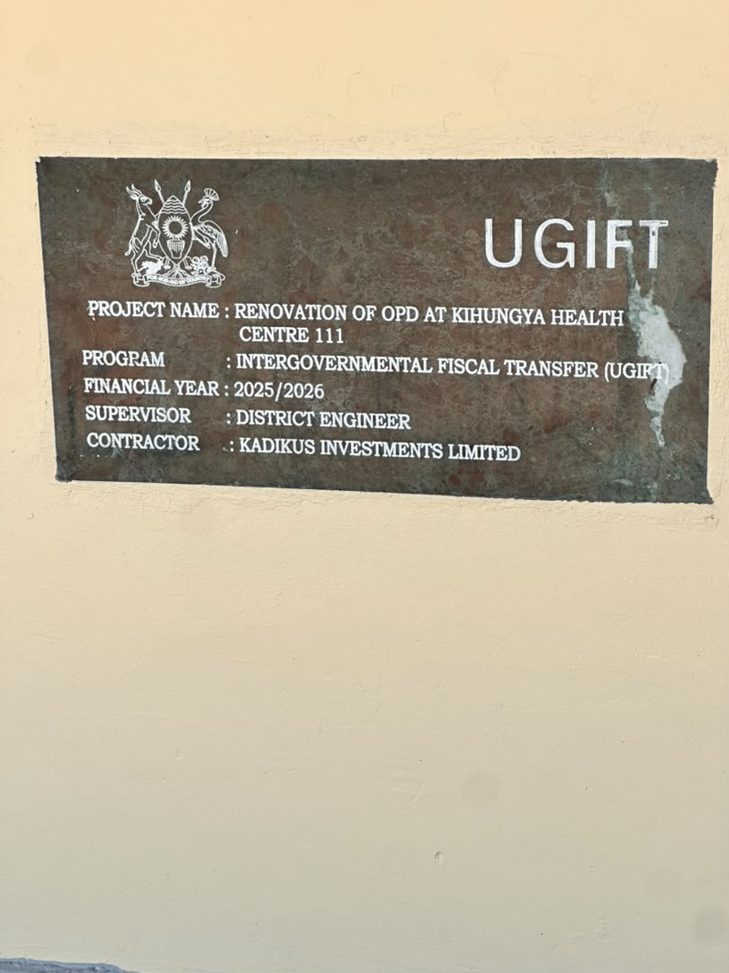
5 | Kihungya Health Facility | 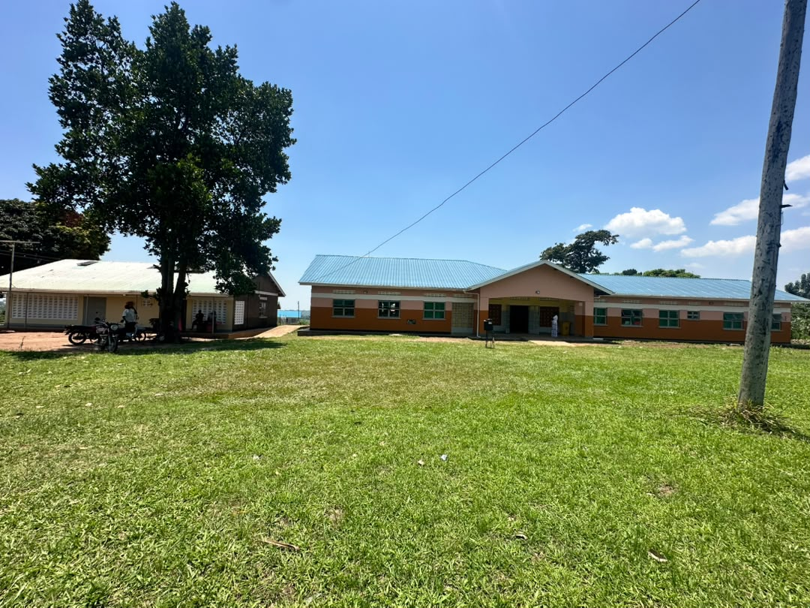
6 | Kihungya Health Facility | 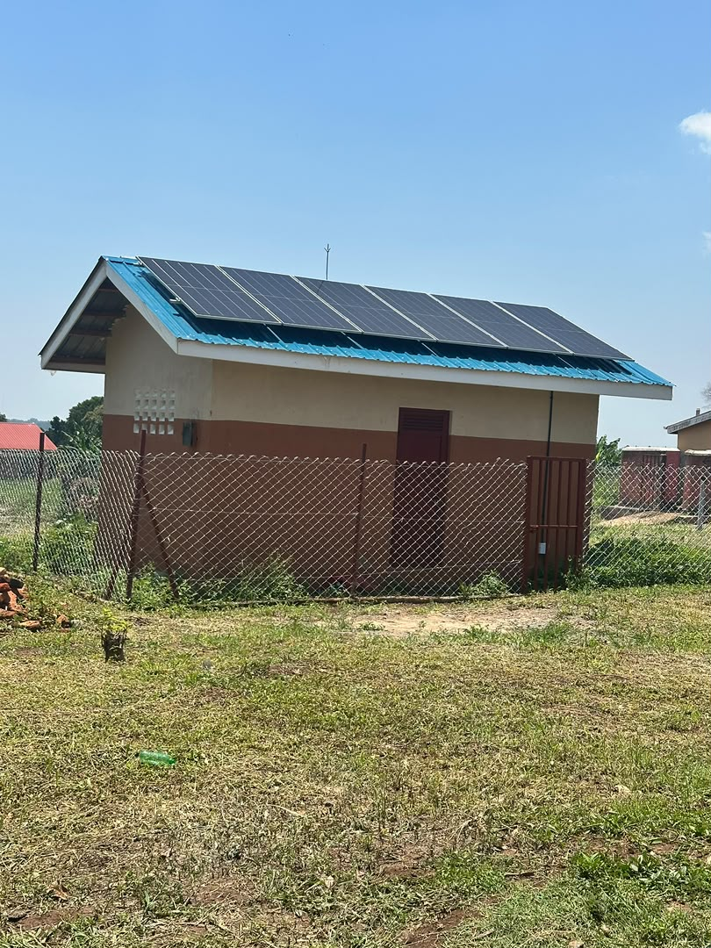
7 | Kihungya Health Facility | 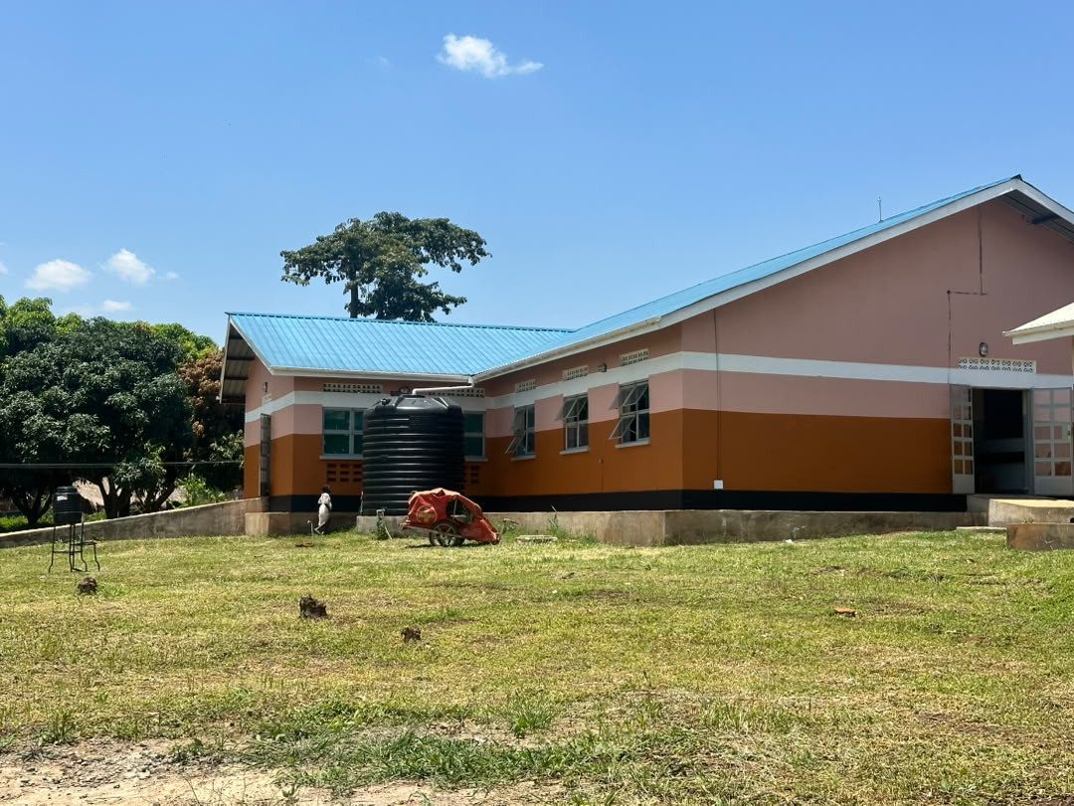
8 | Kihungya Health Facility | 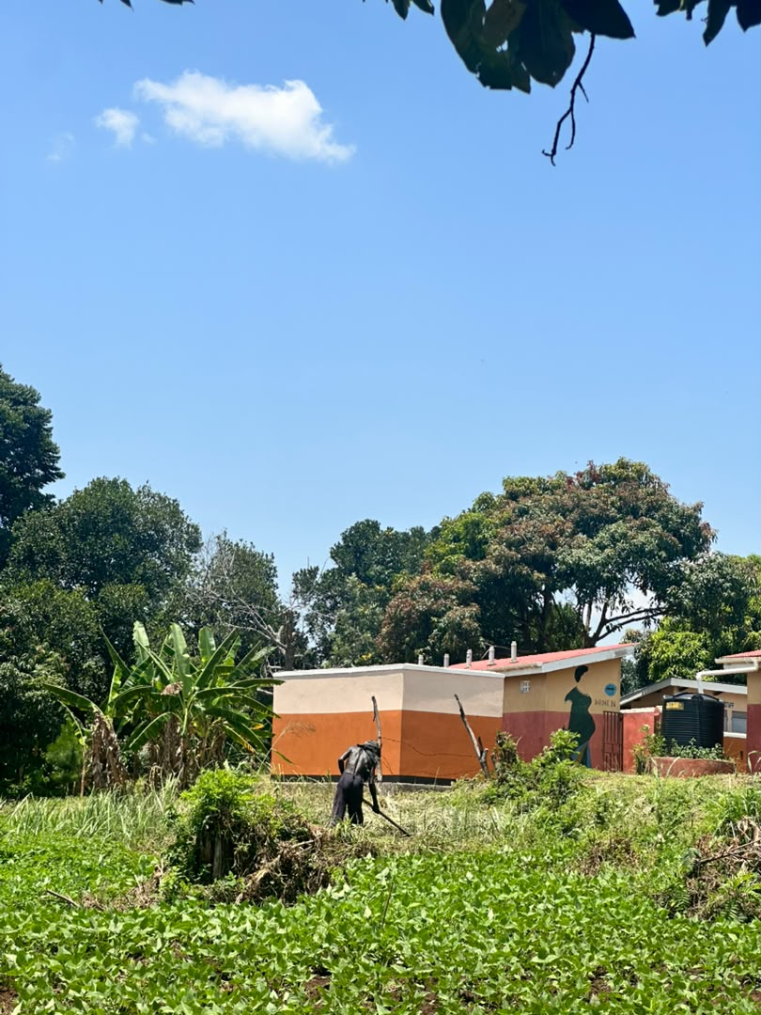
9 | Kihungya Health Facility | 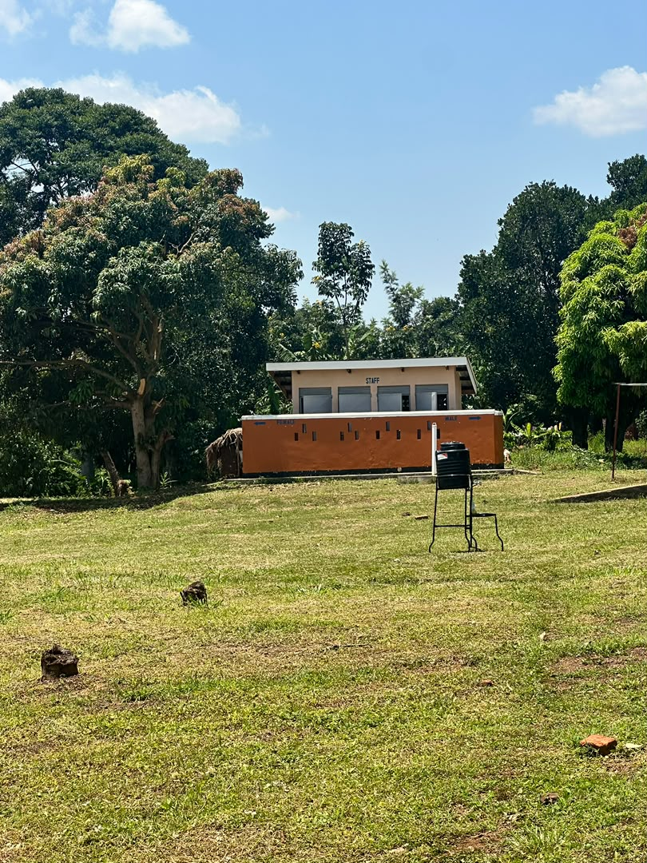
10 | Kihungya Health Facility | 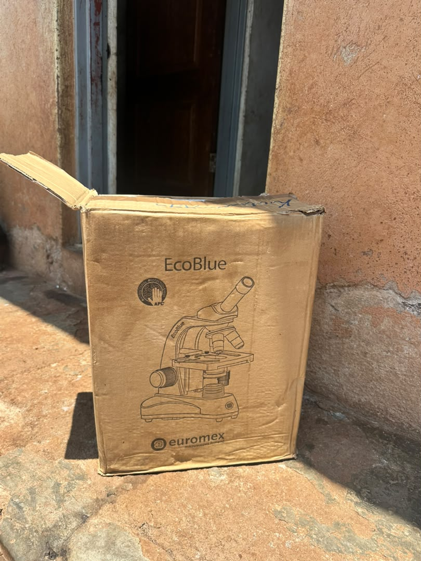
11 | Kihungya Health Facility | 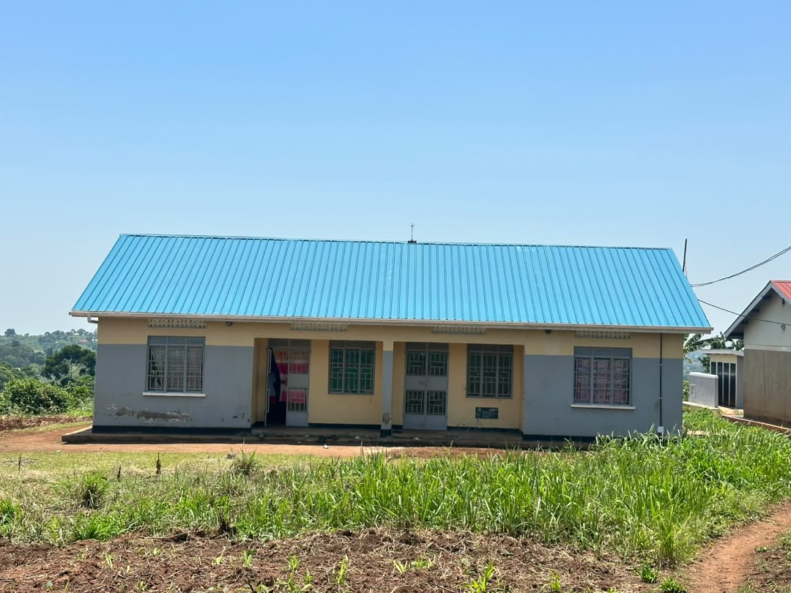
12 | Kihungya Health Facility | 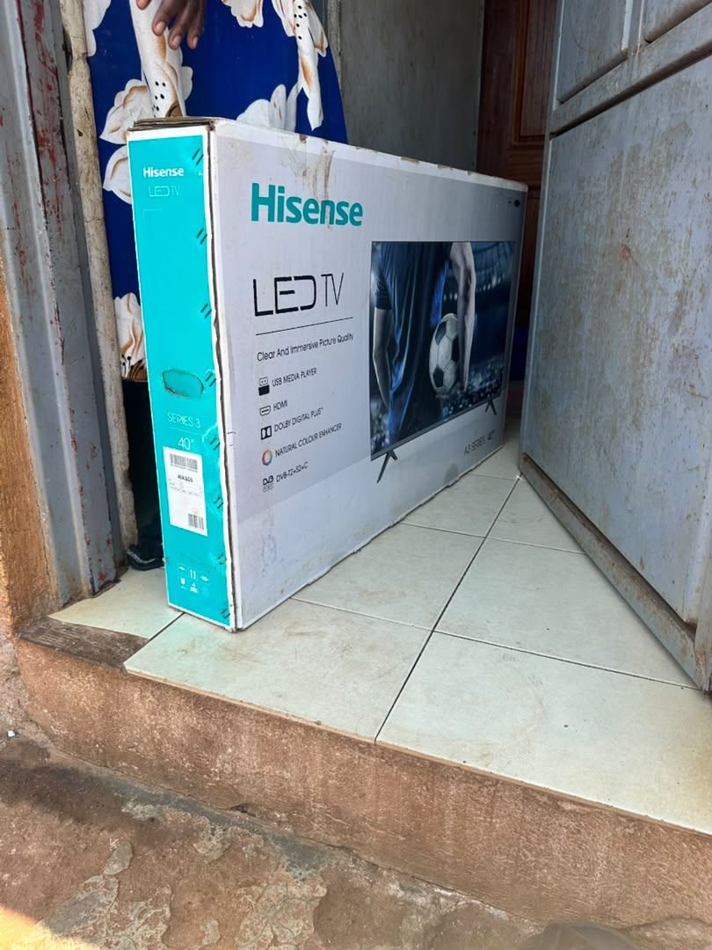
13 | Kihungya Health Facility | 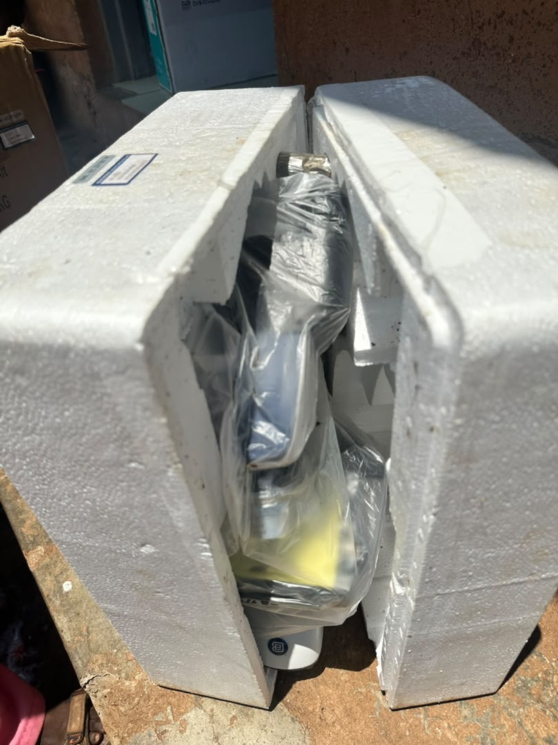
14 | Kihungya Health Facility | 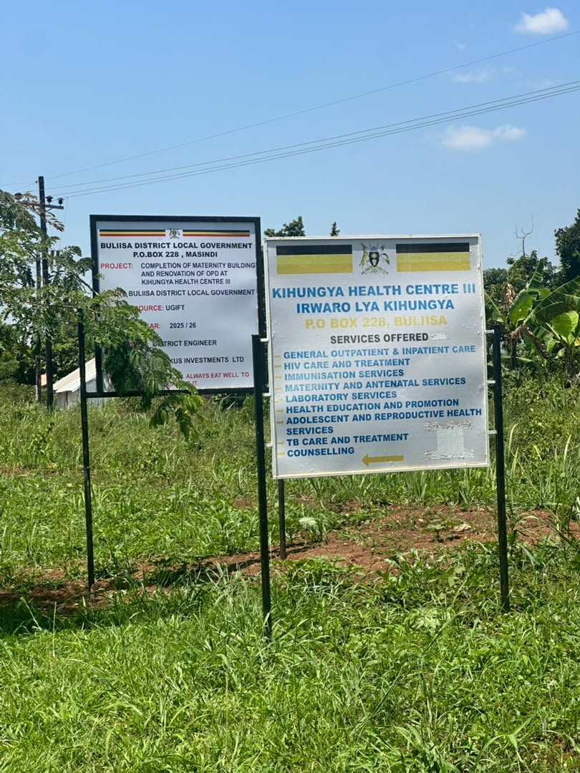
15 | Kihungya Health Facility | 